Westport Scoil Cheoil 2025  Annual Irish Traditional Summer School  14th – 18th July 2025  14ú – 18ú Iúil 2025 | www.westportscoilcheoil.com  087-9185838  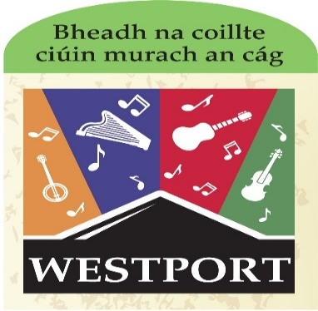  Venue: Scoil Phádraig Westport. Daily 10.00 am to 1.00pm
CLASSES OFFERED:  Classes being offered at  Tinwhistle: 3 levels: beginners/intermediate/advanced.  Bodhrán & Guitar: 2 levels: beginner and intermediate/advanced.  All other classes are offered at 2 levels: intermediate and advanced: fiddle/box/concertina/flute/harp/banjo/mandolin (2 levels on these) NO beginners. Everyone here MUST be able to play 3 polkas off by heart.  Singing: one level. Dance: one level. Piano: one level (must have grade 3).  The very popular Kinder Irish-Music Camp with sean-nós dance/ song and beginner tin-whistle (ages between 5-8). Again, numbers are strictly limited. Early booked essential. First come. First served.  Payment: €100 until 31/5/25. Fee of €115 between 01/06/25 and 15/6/25. No other discount applies. Pay directly to: Maura Thornton.  IBAN IE41BOFI90374415162184 BIC BOFIIE2DXXX.  Do NOT forget to put your name as reference on the bank DD!  OR Revolut @maurathornton 0879185838. NB Include the name of the participant AND complete form below.  This is a limited and confined summer school. We do not accept enrolments without full payment. No places kept without full payment / no deposits taken/ no refund policy. When you have paid online you must also send form to westportscoilcheoil@gmail.com | In order to apply for Westport Scoil Cheoil there are 2 steps.  - Fill in the boxes on this page below.  - Return form with the early-bird fee of €100 before 31/5/25 or €115 after 15/6/25 to westportscoilcheoil@gmail.com  Revolut @maurathornton0879185838  Payment may also be made dropping application form and cash to ‘Ceol’ Castlebar F23PD00 OR CastleVets Westport  Fill in the box below with NAME, PHONE NUMBER, EMAIL ADDRESS & INSTRUMENT to be taken at Westport Scoil Cheoil for the week, LEVEL of class you are attending. Tee-shirt Size

Payment: €90 until 31/5/23. Fee of €100 between 01/06/23 and 15/6/23. No other discount applies. No applications after 15/6/23. Pay directly to: Maura Thornton.
IBAN IE41BOFI90374415162184 BIC BOFIIE2DXXX. Do NOT forget to put your name as reference on the bank DD! This is a limited and confined summer school. We do not accept enrolments without full payment. No places kept without full payment / no deposits taken. When you have paid online you must also send form to westportscoilcheoil@gmail.com.
OR Revolut Maura Thornton 0879185838. NB Include the name of the participant…

Name  NB ensure email address AND phone number are both included | 1.Instrument chosen to study at WSC &  2. Age / Tee-shirt size |  | Level of tuition required at WSC | Are you a TEACHER/ looking for EPV days? Yes/ No | State  Method  Of payment:  Cash/Online/Cheque/Revolut
Email Address must be included |  | Phone Number must be included

GDPR policy: WSC advises that pictures/videos taken of participants enjoying school activities may be used for promotional purposes. NO participant will be named/identified in accordance with acceptable practice. If a participant does NOT wish to be photographed or videoed we ask guardians to please inform WSC in WRITING at the time of enrolment. WSC is not a nut/allergy free zone: please advise WSC about any allergies/medical conditions in WRITING at the time of enrolment. WSC adheres to the Child First Protection Policy: for details of this and all our policies please refer to our website: www.westportscoilcheoil.com. By filling in the form below you agree to the terms, conditions and policies of Westport Scoil Cheoil. All children must be collected at 1pm sharp. Any SEN must be identified at enrolment and SNA’s, if needed, supplied by parents/guardians. No refund Policy: when booked and paid- places are then non-refundable and non-transferable.

