Westport Scoil Cheoil 2023  Annual Irish Traditional Summer School  10th – 14th July 2023  10ú – 14ú Iúil 2023 | www.westportscoilcheoil.com  087-9185838  westportscoilcheoil@gmail.com  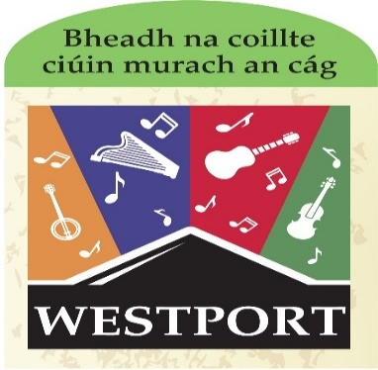  Venue: Scoil Phádraig Westport. Daily 10.00 am to 1.00pm
CLASSES OFFERED:  Classes being offered at beginners/intermediate/advanced on guitar/bodhrán/tin-whistle.  All other classes are offered at 2 levels: intermediate and advanced: fiddle/box/concertina/flute/harp/banjo/mandolin (2 levels on these) NO beginners.  Singing: one level. Dance: one level.  Piano accompaniment: Must have grade 3 on piano and bring your own keyboard and extension lead.  The very popular Kinder Irish-Music Camp with sean-nós dance/ song and beginner tin-whistle (ages between 5-8). Again, numbers are strictly limited. Early booked essential.  Payment: €90 until 31/5/23. Fee of €100 between 01/06/23 and 15/6/23. No other discount applies. No applications after 15/6/23. Pay directly to: Maura Thornton.  IBAN IE41BOFI90374415162184 BIC BOFIIE2DXXX. Do NOT forget to put your name as reference on the bank DD! This is a limited and confined summer school. We do not accept enrolments without full payment. No places kept without full payment / no deposits taken. When you have paid online you must also send form to westportscoilcheoil@gmail.com.  OR Revolut Maura Thornton 0879185838. NB Include the name of the participant… | In order to apply for Westport Scoil Cheoil there are 2 steps.  - Fill in the boxes on this page below.  - Return form with the early-bird fee of €90 before 31/5/23 or €100 between 01/06/23 and 15/6/23 to westportscoilcheoil@gmail.com  Fill in the box below with NAME, PHONE NUMBER, EMAIL ADDRESS & INSTRUMENT to be taken at Westport Scoil Cheoil for the week, LEVEL of class you are attending.

Payment: €90 until 31/5/23. Fee of €100 between 01/06/23 and 15/6/23. No other discount applies. No applications after 15/6/23. Pay directly to: Maura Thornton.
IBAN IE41BOFI90374415162184 BIC BOFIIE2DXXX. Do NOT forget to put your name as reference on the bank DD! This is a limited and confined summer school. We do not accept enrolments without full payment. No places kept without full payment / no deposits taken. When you have paid online you must also send form to westportscoilcheoil@gmail.com.
OR Revolut Maura Thornton 0879185838. NB Include the name of the participant…

Name | Instrument chosen to study at WSC |  | Level of tuition required at WSC | Are you a TEACHER/ looking for EPV days? Yes/ No | State  Method  Of payment:  Cash/Online/Cheque
Email Address |  | Phone Number

GDPR policy: WSC advises that pictures/videos taken of participants enjoying school activities may be used for promotional purposes. NO participant will be named/identified in accordance with acceptable practice. If a participants does NOT wish to be photographed or videod we ask guardians to please inform WSC in WRITING at the time of enrolment. WSC is not a nut/allergy free zone: please advise WSC about any allergies/medical conditions in WRITING at the time of enrolment. WSC adheres to the Child First Protection Policy: for details of this and all our policies please refer to our website: www.westportscoilcheoil.com. By filling in the form below you agree to the terms, conditions and policies of Westport Scoil Cheoil. All children must be collected at 1pm sharp. Any SEN must be identified at enrolment and SNA’s if needed supplied by parents/guardians.

